PROJECT NAME ss

SemesterOrganiser

https://localhost:44331/Home/Index

DATABASE LOGIN: username -st10082757 password -Wandisa2002

TARGET FRAMEWORK: 6.0

# Installation

1)Open SemesterOrganiser Task and click on the sln file with the visual studio IDE.

2)Go to solution explorer on your right

3)Right click Connected services and go to MANAGE CONNECTED SERVICES

4)On CONNECTED SERVICES page find SQL Server Express LocalDB(local) click on the three dots (...) then EDIT DEPENDENCY

5)On the EDIT DEPENDENCY page click LOCAL USER SECRETS FILE on SAVE CONNECTION STRING VALUE IN

6)On the EDIT DEPENDENCY page click the three dots on CONNECTION STRING VALUE

7)On the SQL CONNECTION STRING page change the SERVER NAME to "dbs-vc-cldv6211-st10082757.database.windows.net"

8)Then change AUTHENTICATION to "SQL Sever Authentication"

9)The username is st10082757

10)The password is "Wandisa2002"

11) On Select or Enter Database name select Semester

12)Click the TEST CONNECT button on the SQL CONNECTION STRING window

13)Press next

14)Press Finish

15) Build Application

16) Run Application

INTRODUCTION

The Semester Organizer is a comprehensive application designed to assist students like Lerato in efficiently managing their academic workload. The application addresses common challenges faced by students during hectic periods, such as project submissions, lectures, tests, or exam weeks.

WHY THE PROJECT WAS MADE

To manage the challenges faced by students during the hectic period of project submissions, lectures, test, or exam week. The challenges being:

-Deadline Pressure: Students often find themselves rushing to complete assignments just before the deadline, leading to sleepless nights and burnout.

-Coursework Management: Keeping track of multiple modules, credits, in-class hours, and self-study time can be overwhelming.

-Lack of Organization: Without proper organization, students may miss deadlines, forget important tasks, or neglect their well-being.

NB: the edit, details(view) and delete functionality look the same and function the same that is why only one side of screenshots are provided

INSTRUCTION GUIDEss

2- The main window will display for users who have logged in or are logged off, registered, or not. 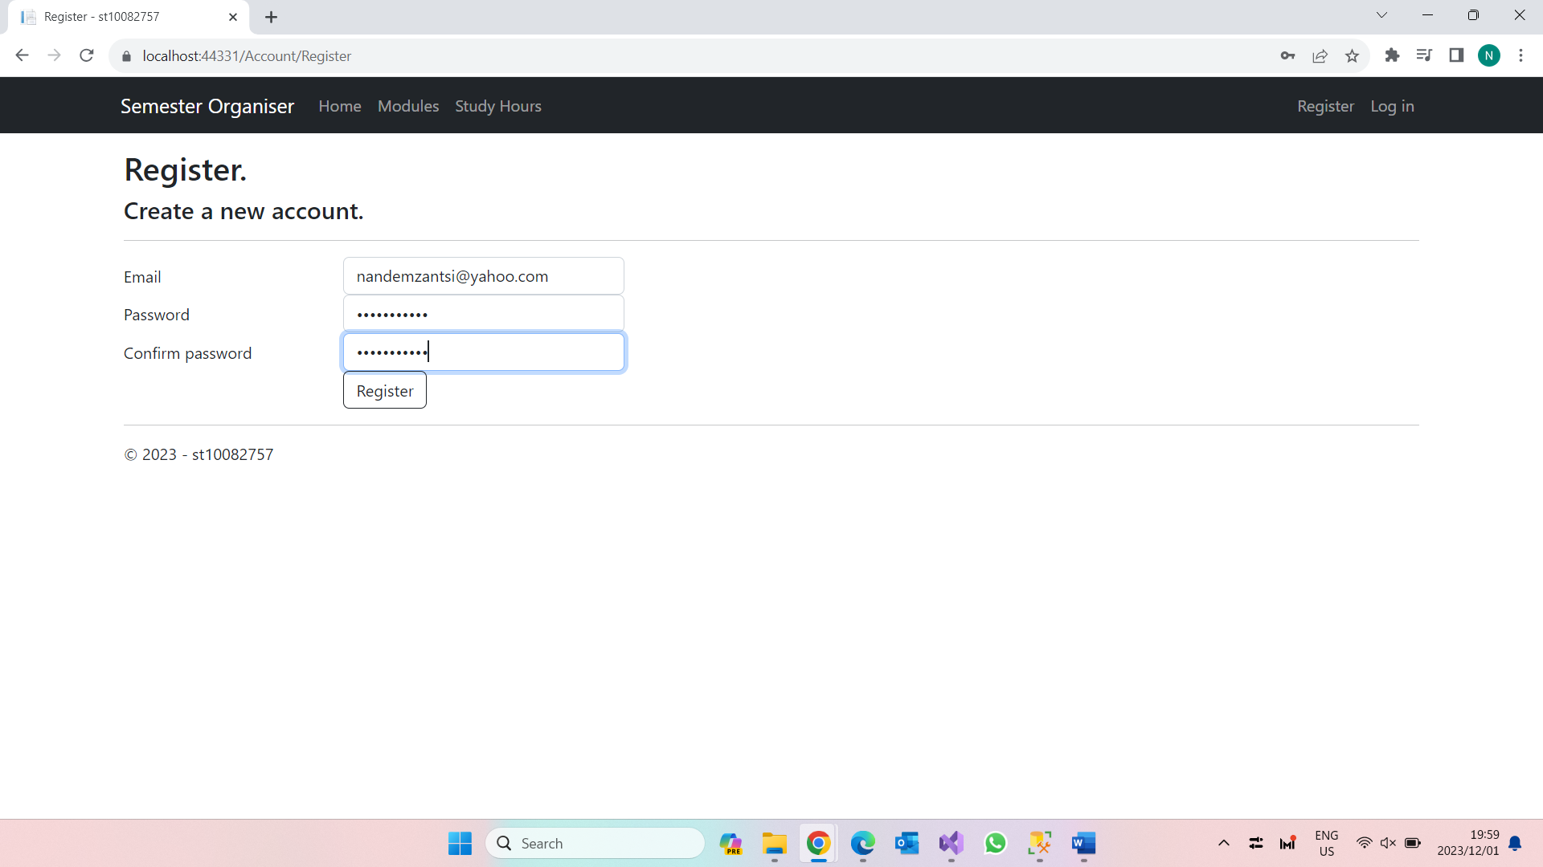

4- Once you click register you will be taken to the home page 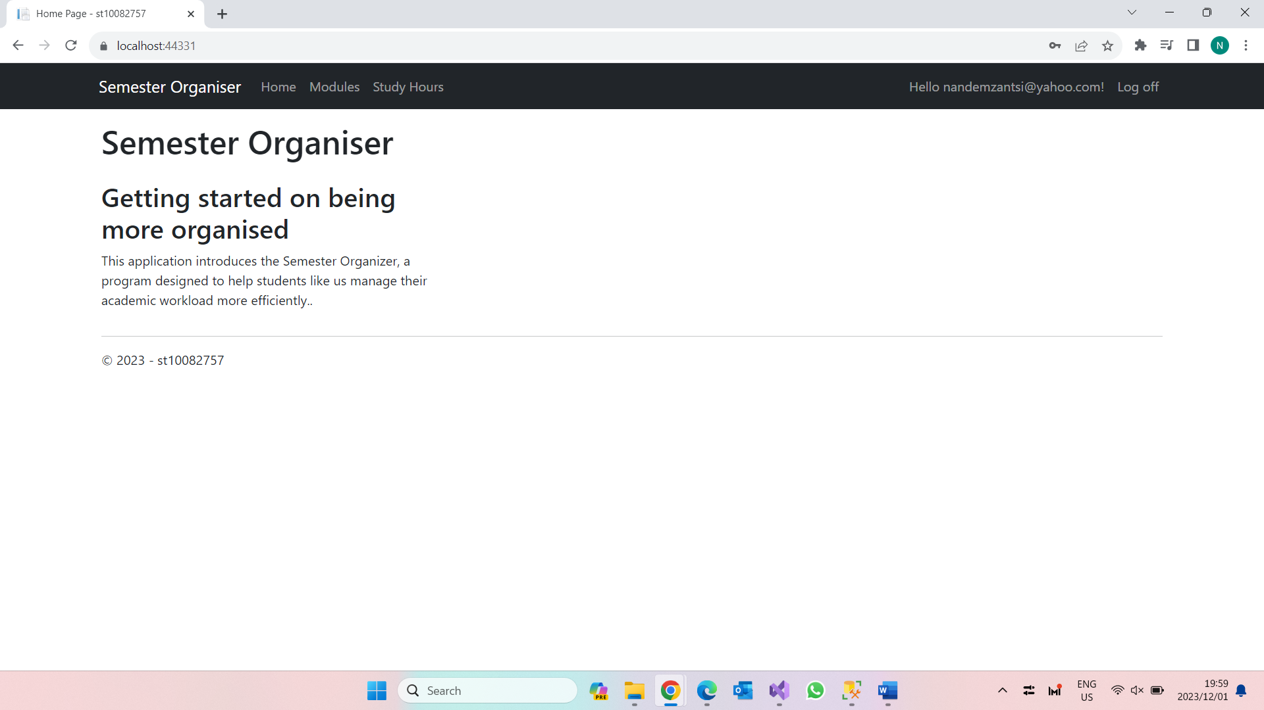

5- then you can click on the modules tab where you can click create new in order to add new values, edit in order to change something and details in order to view them in list format and delete in order to remove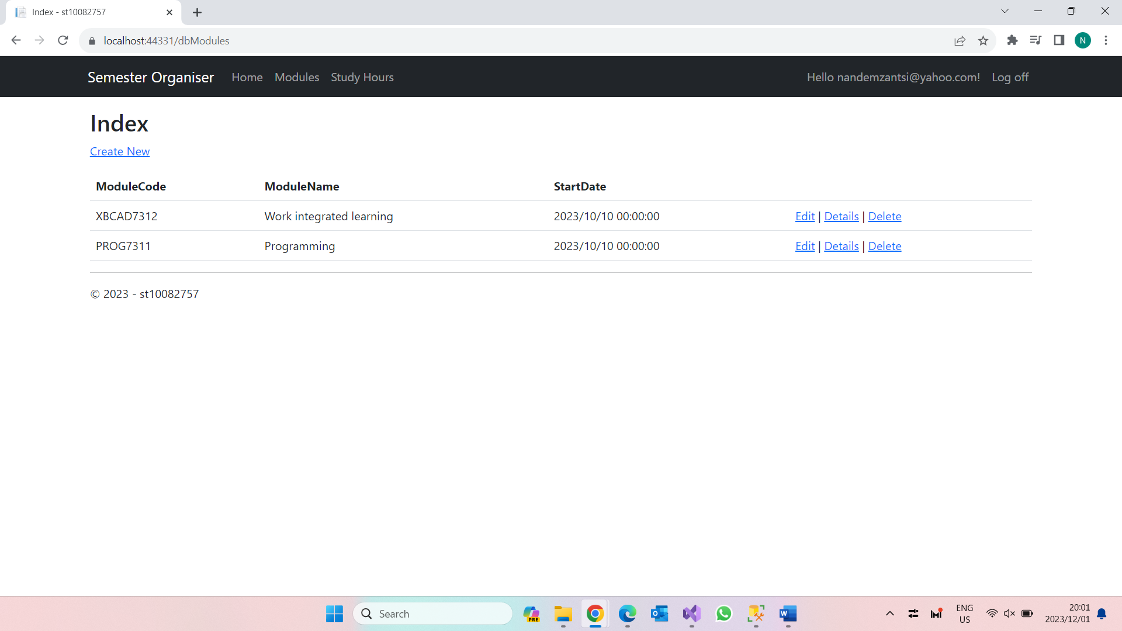 7- how it will look when you add values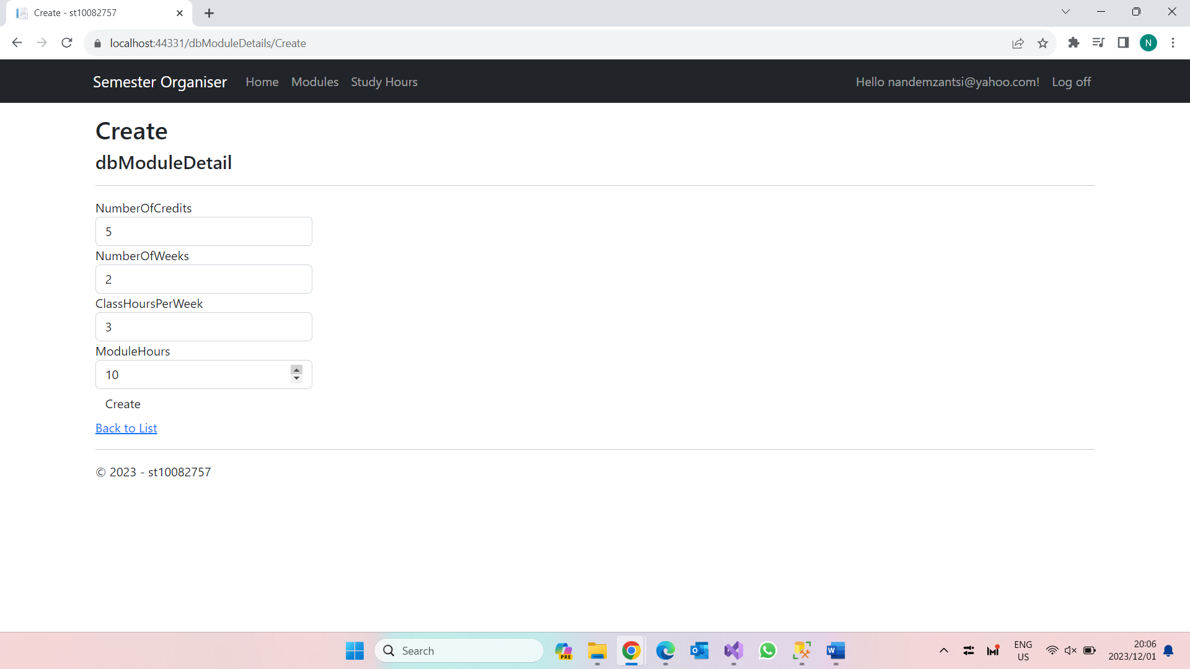

10- Now ive logged off

